Service-Sheet Metal Fabrication
Demo knowledge file for Content Studio | Sheet Metal Fabrication
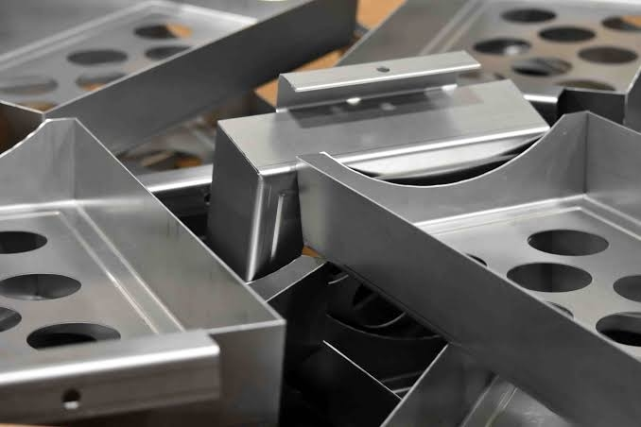
Representative image for Sheet Metal Fabrication service content.

Service Summary
Sheet metal fabrication support for laser cutting, bending, welding, stamping, and custom metal assemblies.
End-to-end sheet metal services: laser cutting, bending, stamping. We produce precise enclosures and parts for various applications.

Typical Applications
- Stamped components
- Brackets and enclosures
- Custom panels
- Connector assemblies
- Prototype sheet metal parts

Material Coverage
- Stainless steel
- Aluminum sheet
- Carbon steel
- Galvanized steel
- Copper sheet

How Content Studio Should Use This File
- Use this service summary as source material for service pages, blog articles, landing pages, and RFQ-oriented email copy.
- Use the applications list to match service content with buyer scenarios and AI-generated article sections.
- Use the source URL when the generated content needs traceable evidence or a reference link.

Crawled Page Headings
- Service
- Sheet Metal Fabrication
- Find Content
- Explore
- Get In Touch
Source: https://www.rejincnc.com/service/sheet-metal-fabrication/

